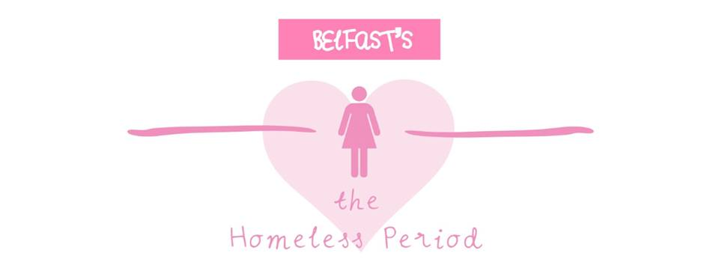
The Homeless Period Belfast is a volunteer led campaign, providing homeless and vulnerable women across Belfast with sanitary and other hygiene items. With a mixture of donations and funds, we make care-packs full of sanitary products which are then delivered to various shelters, food banks and rough sleepers across the city.

We desperately need donations to help women in need.
Can you help us?

Please donate: Sanitary Towels, Tampons, New Underwear and Hygiene Wipes

Thank you for your support!
https://www.facebook.com/TheHomelessPeriodBelfast/
@homelessperiodbelfast
