Unison Retired Members Forum Newsletter
December 2016
Issue 1
Inside this issue
1/2 Tributes paid to colleagues.
2 Eddie Lynch takes up new post.
3 New CEO at Age Sector Platform.
4 Northern Ireland Pensioners Parliament a great success.
5 Unison Retired Members Conference in Southport.
6 Massive Change to the Political Landscape.
7 Fuel Poverty numbers set to rise.
8 Bengoea report: What will it mean for our Health Service in NI.
9 Ofgem fails to tackle Energy Market.
10 Cost of care in a home reaches new high.

Tribute to Jonathan Swallow a colleague to all. Back in 1st June this year Unison learned of the death of our dear colleague and friend Jonathan Swallow. For over 30yrs he was an outstanding campaigner in fighting for the rights of the working class people within the public services.
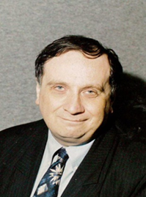
Through his efforts Jonathan campaigned to keep our public services free from becoming privatised. He campaigned long and hard against privatisation in our Health & Social & Social Care Services which led to all the Domestic and Catering Services returning to in-house. He became a ‘hero’ in the eyes of many of the low paid workers whom he cared so much about. Indeed he was involved in lots of work with Unison here in NI. Jonathan was a true and committed champion for the rights of all workers. He will be sadly missed by all who knew him in the office and beyond. He always had a good morning and a smile for you even though he may not have known your name. A celebration was held at Unisons

HQ in Belfast on the 28th September to celebrate his life and work. There was a great attendance by members of the forum and our own Anna Mc Gonigle took part in paying tribute to a great man. He will always be remembered as a true champion for ever in everyone’s eyes.
Tribute to Dorothy Hutton our friend and colleague. On the 29th July 2016 we all learned of the sad passing of our dear retired member, friend and colleague Dorothy Hutton. She had been battling with terminal illness for a lengthy period in her life but didn’t let it bother her as she continued to get on with life. She believed in helping and caring for those in need. She became a member of Unison on 1st July 2004 and became active in committees such as Welfare and the Retired Members forum. Most people will remember her helping out in the kitchen with her niece Caroline at the Unison building. Dorothy was self-employed, working from home and she always had a caring nature about her always thinking on those in nursing homes whom she made time to visit. She became involved with the National Retired Members Committee and attended the conferences in England where she give excellent accounts of the work of the retired members here in NI. She also admired the work been done for Older People and became involved with Age Sector Platform through a local NIPP Parliament in in her area.
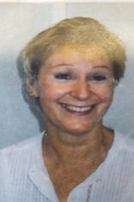
Dorothy was also a keen bowler and got involved with her local bowling club which give her a great social life meeting other people.
Former CEO takes up new post. Delegates and Members of Age Sector Platform saw big change taking place in its ranks back in June when Eddie Lynch (former CEO) took up his new post as The Commissioner for Older People in NI. In his post as CEO he was a big champion for the rights of Older People and will be greatly missed. Under his leadership he had a great team of people who give him excellent support and whom he appreciated very much. At his final plenary meeting back in May Eddie spoke of the wonderful time he had working in Age Sector Platform and spoke highly of the great support from his team, the delegates and the members. As Eddie moved on it left a vacancy to be filled and so Age sector Platform had to start planning to look for a new CEO. To the very end Eddie was at hand to lend his support, knowledge and experience and was there to offer advice on any issues and matters arising. At the final meeting Eddie (right) was presented with a beautiful collage of photos depicting his time with Age Sector Platform.
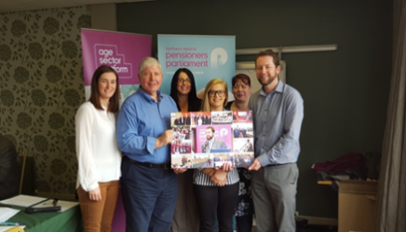
We wish Eddie all the best for the future in his new job as The New Commissioner for Older People NI and it is hoped that a planned visit for this forum will become a reality in the near future.
New CEO for Age Sector Platform appointed. The task now lay ahead for Age Sector Platform to get on with looking for a new CEO. A subcommittee was set up to carry on with the delegate task of putting together an interviewing panel consisting of three delegates. This was to be quite a unique experience for some of the people sitting on the subcommittee and a decision had to be made to who would sit on the panel. At this point legality and equality played an important part in the decision to elect the panel. Delegates who were finally elected to the panel had a great opportunity to gain a lot of experience and knowledge from doing interviews. Indeed the panel had to familiarise themselves with the interviewing process, draw up questions to be asked and come to a final decision. After three days of interviews, deliberation and digesting the panel finally came to a decision and elected Eamon Donaghy as the new CEO. Eamon is seen here at his first two day Pensioners Parliament event held in the Clayton Hotel in Belfast back in October.
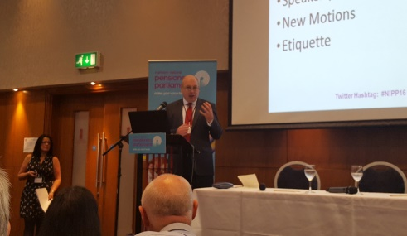
NPC Dignity Day event NI
The National Pensioners Convention NI is to hold a half day seminar in the Unison Centre at York Street on the 1st February 2017. A number of speakers have been invited along from various unions and organisations to talk at the event including the new Commissioner for Older People NI. In 2013 the NPC in Northern Ireland developed a Dignity Code after the media highlighted that Older People were not being cared for properly in our hospitals. Last year the event was attended by a large group of people. The seminar is open to everyone and would encourage a good attendance from the forum. It is hoped to have our own Patricia Mc Keown (Regional Secretary) speaking as well.

Northern Ireland Pensioners Parliament two day event a great success This year’s two day Pensioners Parliament event held in the Clayton Hotel in Belfast on the 13th and 14th October turned out once again to be a great success. In the lead up to the event the Pensioners Parliament held 11 local Parliaments across the region.
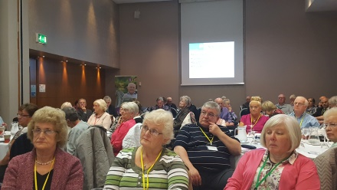
In some of our local areas members of the forum got to open the parliaments in their areas. Behind the scenes the office staff had been so busy working hard to make the event a big success. The new committees were hard at work also developing the motions for the two day parliament. The information that was gathered from the parliaments was used as part of the structure to determine the Agenda for the event. The sessions at this year’s event ranged from the Programme for Government, Health & Social Care, Transport and Westminster Issues. Among the people invited along to the event were the Junior Minister/s, Robin Newton (Speaker of the Assembly), Minister for Health & Social Care, the Commissioner for Older People and the Dept. of Infrastructure. As delegates and members began to gather on the Thursday morning news began to filter through that the Health Minister and the Junior Minister, both from the same party had rang at the last minute to say that they had other engagements and couldn’t come. There was dismay among everyone when it was announced as the office had put a lot of organisation and hard work into planning the two days. However at the last hour Mike Nesbit leader of the UUP stepped in to talk on the Programme for Government and the Health Minister sent along a civil servant from the Dept of Health by the name of Chris Mathews to deliver her presentation. As everyone began to settle down the two day event got under way at 10.30am and Session 1 began with the Chair of the NIPP Anne Watson welcoming everyone present. She then handed over to Robin Newton (Speaker of the Assembly) who began by acknowledging the numbers present saying that ‘it was humbling to see such a large presence at what is a great event for Older People. In his speech he said he was looking forward to chairing the Plenary event in Stormont in February and was happy to announce that it would be held in the Main Chamber in 2017. Eamon Donaghy (CEO) was next to speak and he began by introducing himself and outlining his background. He went on to deliver his presentation on the Format for the NIPP. Eamon spoke highly of how he was part of a great organisation and praised the wonderful staff with whom he was working with and looked forward to working with in the future. After Eamon completed his presentation Mike Nesbitt give the Parliament an overview of the Programme for Government (PfG).In his presentation he outlined how the Programme for Government was an outcome based accountability and that there was no mention of Older People in it.
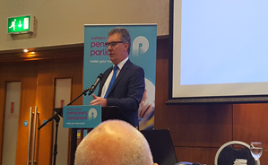
The parliament was concerned when Mike mentioned the fact that Goods, Facilities and Services was not even in the departmental plan. The draft programme is due out for consultation soon so we will be keeping an eye on this. He went on to say that the Pensioners Parliament need to make a lot of noise sooner rather than later if we are to make a difference for the future. With the NHS slowly crumbling and the Bengoea Report due out next month resources are very limited. Questions and answers followed the presentation by Mr Nesbitt. In Session 2 Chris Mathews (Dept of Health) stood in for the health minister who sent her apologies at the last minute. He outlined to the parliament that the Health Service was facing a range of financial pressures and was working on a budget of £5 million pounds per year. He said that future planning was under way and that there were even more demands on the Health Service. The health minister scrutinised the Bengoea Report with the view to looking at a 5 – 8yr vision for the service. Domiciliary Care he said is going to be reviewed with the service being under intense pressure. It was pointed out that Domiciliary Care in the West was going to be put out to tender. On Friday (day 2 of the Pensioners Parliament) the morning got off to a good start at 10.30am with everyone settling down to listen to a person who needed no introduction to the Parliament. A rapturous applause rang out as Eddie Lynch stepped up to the podium as the new Commissioner for Older People NI to deliver his presentation. Eddie began with his sense of humour shining from the onset. He then went on to outline the background to his office. He began to say that a strong campaign had been led to get a Commissioner for Older People in NI (CoPNI). His principal aim is to be a champion for Older People and promote positive attitude. He will promote an end to discrimination and encourage best practice. Eddie spoke out against Audiology waiting times and said that these need to improve. He has been out and about to get the views of Older People.
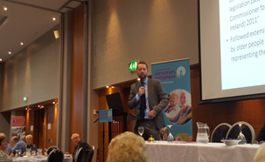
Tackling Elder Abuse is going to be one of the Commissioners priorities in which he will be looking at tackling this issue head on. In September this year the Commissioner’s office launched a publication called ‘Financial Abuse of Older People in Northern Ireland: The Unsettling Truth’ and is available to everyone. Eddie was also shocked to find that the Draft Programme for Government had no mention of Older People but in contrast it had mentioned young people up to 20 times. Eddie advised government to include another outcome ‘We respect, value and protect our Older People’. The new Commissioner certainly has his finger on the pulse and will continue in his efforts to champion the rights of Older People. After the Commissioner finished his presentation he was given a very warm round of applause from everyone attending the parliament. Next on the Agenda was the launch of the ‘Northern Ireland Pensioners Parliament Transport to Hospital Appointments Report 2016’.
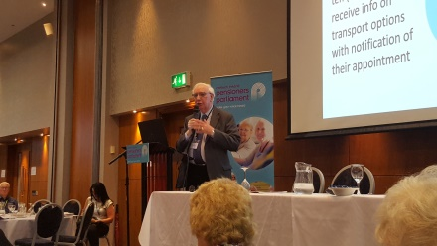
The report was launched by Francis Hughes (Chair, ASP Transport Committee) at the parliament in which Age Sector Platform carried out a survey on the issue. Some of the highlights coming out of the findings found that: 51% of Older People selected Transport as a top concern. 45% said that they experienced difficulty in travelling to hospital appointments in the last two years. 19% said they had to cancel hospital appointments due to problems with Transport. 14% missed a hospital appointment due to transport problems. This is just a small flavour of what is to be found in the report. A copy has been made available to everyone at this forum. Session 4, the final session of the day centred round Westminster Issues Political panel discussion. This discussion and debate round the many issues affecting Older People always gets the attention of the delegates and members. On the panel’s hot seats for the event was Gavin Robinson (MP,DUP), Margaret Ritchie (MP,SDLP), Mickey Brady (MP,SF), Danny Kinahan (MP,UUP) and Stewart Dixon (MLA, Al). The range of topics questioned from the floor was on such things as The New State Pension, information on benefits/entitlements, energy prices, exclusion from the Warm Home Discount Scheme, Implications of Brexit for Older People, the impact of falling interest rates for OP with limited savings and the increasing state pension age. Indeed people where not afraid to express their concerns to the ministers and everything was taken on board by the panel. Finally the Chair of Age sector Platform Michael Monaghan closed the parliament with his speech thanking everyone for their attendance. The Unison Retired Members Forum would like to thank most sincerely Eamon, Seamus, Alison, Eleanor, Nichola and Julie for all the hard work they put into running the event. Very Well Done
Get involved now
Age Sector Platform (Pensioners Parliament) are always looking for new members to get involved in making a difference for the rights of Older People.

Unison Retired Members Conference at Southport
Back in October this year Unison Retired Members held their Conference in Southport. The atmosphere was nice and relaxed with everyone going about their business with the various stalls about to advise you on anything you wanted to know. Attending the conference was Martin Gallagher (Delegate from the Retired Members Forum) and Victor Murphy (Delegate from the Belfast City Hospital).
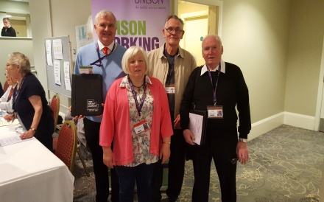
Other members attending the conference from this forum were Angela Boardman, Joy Griffiths and Alan Jones who all had a part to play relating to the conference. On the first day of the conference delegates from the various retired members groups got together with delegates from other regions and began settling into the spirit of what was going to be a great event. There was lots of stalls for the delegates to visit and delegates had the opportunity to sign up to the discussion event of their choice. It was clear speaking to delegates across the water that we are very well organised here in Northern Ireland. We have a Pensioners Parliament (ASP) at which our older people are able to have a voice as to how our services are run. We have an excellent campaigning strategy to ensure we get what we are entitled too and let’s not forget that we have something which we heavily campaigned for and that’s a Commissioner for Older People NI. We also have a great Transport system in place together with great Education, Health and so forth all being run by Stormont. Across the water it is a completely different picture altogether. Local authorities/councils run all the public services like Health, Transport and Education something which we should never let happen here. A number of discussion groups where set up for Delegates which all began in the afternoon. They were on the following topics; Transport, New Delegates, Pensions and Fighting against Dementia. The forums Delegate Martin Gallagher took a keen interest in attending the Transport discussion on ‘The Buses Bill’ as transport came out as one of the top three issues at the Pensioners Parliaments held locally which affected Older People in NI. During discussion it was very clear that local authorities/government was in the process of introducing a ‘buses bill’ which would enable Mayoral authorities to franchise the service. Concerns were also raised that the bill would enable regional ticketing and pricing schemes to take place and ban councils from setting up municipal bus companies. Local Authorities have also decreased the funding and this has left the bus service in crisis. Rural services have suffered due to austerity and cuts. It was clear that bus services in England, Scotland and Wales where in decline. Local delegates are in the process of leading a big campaign ‘Save Our Buses’ in England, Scotland and Wales and have urged everyone to lobby their councillor’s in their constituencies for a better way forward. What I could gather from speaking to people it was clear that campaigners would need to up the ante if they are to get anywhere in making a difference in getting to grips with cuts in rural areas. More also needs to be done to access free transport both in buses and trains for older people in England, Scotland and Wales. It is morally wrong that older people who have paid their taxes all their working life and are still paying their taxes across the water has no access to free transport.
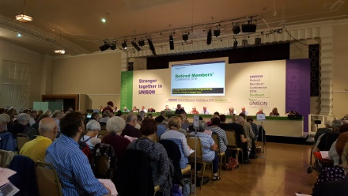
In comparison if anything was clear, it was that we have one of the best services that Translink run for the people here. We should never let our service crumble and more importantly we should never let our Councils/Authorities take over our public services. Over here pensioners have one of the greatest things here which can get us anywhere free at age 60+ and that’s our Bus Pass/Senior Bus Pass. Our Bus Pass/Senior Bus Pass can end up taking us from A – B by road or rail. Depending on your age you can travel the full length of Ireland using the pass. At age 60-65yrs you can travel anywhere in the North by Bus or Train using your smart pass. At age 65+ you can travel anywhere North or South using your Senior Smart Pass which you can apply for when you reach the age of 65yrs. This is something worth keeping when we have it and should never let it be taken away from us. In comparison across the water pensioners have a bus pass which they can use on the buses but not the trains. It was learned that the only time that pensioners can use their pass was from 9.30am – 3.30pm in the afternoon. After that they have to pay a full fare, pass or no pass. It also immerged that if you want to use the railways using your bus pass then you have to pay an extra £500 for the year. This is something to think about if government ever try to do away with our pass here. The Branch delegate Victor Murphy took a keen interest in attending another important discussion on Pensions. Unison Retired Members led by Glyn Jenkins (Head of Pensions) are in the process of heading up a big campaign on pensions ‘Protect Our Pensions’. Pensions are a very big topic for all pensioners receiving the benefit at the moment with the introduction of the two tier system back in April of this year. The discussion was very informative and lots of concerns were raised. The Retired Members forum will be keeping a strong eye on developments regarding our pensions and information gained at the discussion has been copied for everyone. The conference was informed by the Chair of the Nat. Retired Members Committee Rosie Mc Gregor that Unisons Retired Members had risen from 170000 to 170800 which show that this union has by far the biggest number of retired members in comparison to any other union in Great Britain.

Massive Change to Political Landscape.
Since we last met back in May a lot has changed in the political front. People had the opportunity to take a vote on whether to stay or leave the European Union. David Cameron (former Prime Minister) felt it was important for everyone in Great Britain to have their say. So the vote took place and the people voted to leave the European Union. Cameron is now no longer Prime Minister (not that he will be missed) and now we have Theresa May in place as the new Prime Minister. In our own region NI we also have seen a new change after the elections back in May. The DUP and SF were once again voted in as the two main parties. The UUP decided to become an opposition to the two main parties and the SDLP joined them. Will anything come of it? It will be interesting to see if this will really work and we will be closely keeping an eye on it. Then recently the big political earthquake happened in America when the people voted Donald Trump into power over Hilary
Bus Run 2017 for the Retired Members Forum.
As you know we were unable to have our bus run this year due to unforeseen circumstances. We should now think about our bus run for next year and where we want to go. It is very important that we are able to get together and have some relaxing time together. Maybe when we are discussing our run out we should maybe look at some help from Unison Welfare and see if they will be willing to put some funding to our trip. This is something we as retired members should always keep up on a yearly bases. Social outings like this will help to boost our moral and always have something to look forward too.

Clinton as the new 45th president of the USA. It was a big shocker for everyone knowing what kind of a man he is. It will be interesting to see what kind of country America turns into now that he will be holding the reins in the White House.

Fuel Poverty Numbers set to Rise
Since we know now that a Brexit is going to be triggered in 2017 there has been lots of concern arising out of the fact that food prices are on the rise in our supermarkets. It has led people to believe that there can be no doubt that other price rises will follow such as oil, fuel, electricity etc. This may well lead to a hike in Fuel Poverty numbers and once again older people will begin to suffer and may have to continue to make the choice whether to ‘Heat or Eat’. Everyone would like to think that this will not be the case but it could become a reality in the future. We will be keeping a close eye on this issue as things begin to develop after the Brexit.

Bengoea Report: What will it mean for our Health Service in Northern Ireland?
Back in October the new Health Minister Michelle O Neil (SF) launched the latest report into our Health Services in NI. One of the big aims for the Minister is to try and reduce the waiting lists within our hospitals but she has also downplayed the significance of the lack of extra funding to address this issue in the Executive's quarterly reallocation of departmental funds. Mrs O'Neill was giving evidence to her Stormont scrutiny committee on her newly published 10-year plan to restructure health and social care in the region.
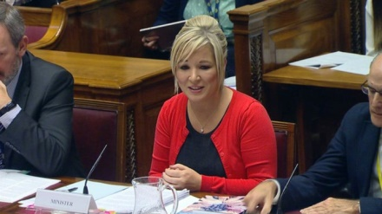
The health minister is committed to the transformation of care from our hospitals to our community but is the money really there to carry out this care in our community. While Mrs O'Neill's department received some extra funding in this week's October monitoring round announcement, none of it was to tackle waiting lists. This has prompted questions over the Executive's commitment to deal with the problem. The Northern Ireland Executive is determined to transform health and social care to ensure world class services for all of its people, the First and deputy First Ministers have said. Key aims include: Moving away from hospital centred care. Moving towards concentrating specialised procedures on a smaller number of sites. Increasing the emphasis on prediction, prevention and health promotion. Providing a structure for better patient engagement. Investing in and building capacity of networks of existing health and social care providers. Investing in eHealth to support improved self-management, care at home and use of information.
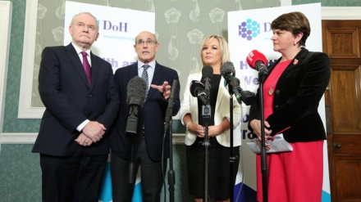
So what does this mean for us as patients? In the future we may well be looking at the running down or closure of some of our hospitals here in the region. Money/funding is always going to be the big problem to transforming any care as care needs will become greater in the future.

Ofgem fails to tackle energy market.
The NPC newsletter reported that Ofgem’s so called shake-up of the energy market has done very little to address the real problem facing older people I Britain. Each year thousands of pensioners die needlessly from cold related illnesses mainly due to the fact that the UK as a whole has a terrible combination of poor housing stock which is difficult to heat, low pensioner income and ever increasing fuel bills. Off-course Ofgem has made recommendations that costumers receive prompts on their bills or letters urging them to switch doesn’t help knowing that the majority of pensioners have never been on line or never use computers in their lives. There are more efficient ways to help people who are struggling with bills etc., and that is to put them on a cheaper rate. Better still a suggestion was made to bring the energy market back into the public domain.

Cost of care in a home reaches new high
The NPC has highlighted in their newsletter that the cost for those facing care in a home is facing average fees of up to £30,000 according to a study carried out by one of the biggest care agencies in England. Prestige Nursing highlighted that fees where rising ten times faster than the pensioner income. It was even noted that a fifth of wealthiest pensioners who have an income of nearly £20,000 per year were unable to pay care home costs without also relying on their savings. Under the current system anyone with savings will have to spend their money before receiving any support from government and many will end up selling their homes to pay their care bills. Jan Shortt NPC vice president said ‘Tax-funded health & social care is the only way to ensure everyone gets the support they need, free at the point of delivery’. This is a story we will be keeping a strong eye on as it develops.

