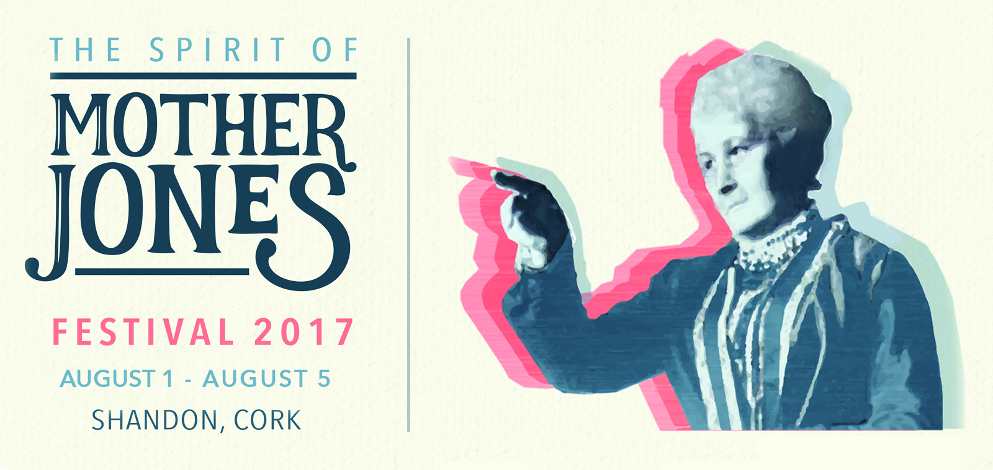

Spirit of Mother Jones Festival and Summer School 2017

The 2017 Spirit of Mother Jones Festival and Summer School will again be held in the Shandon Historic Quarter in Cork, over five days from Tuesday August 1st to Saturday August 5th 2017.

Hundreds of visitors are expected from all over Ireland, the UK and the USA for what is now one of the largest public history festivals in Ireland, featuring over 30 separate events.

2017 marks the sixth annual festival held in Shandon, all events take place at the Maldron Hotel or the Firkin Theatre and all lectures/talks and films are free and open to the public.

The festival celebrates the life of trade union activist, Cork born Mary Harris, better known as Mother Jones and all events are dedicated “to inspirational people everywhere who fight for social justice”

Among the confirmed speakers this year are writer Manus O’Riordan, author and environmental campaigner Fr Sean McDonagh and journalist and author Frank Connolly as well as trade unionist Ethel Buckley, who led the Clery workers campaign.

The Cork Mother Jones Committee is especially proud to accept a unique endorsement of the Mother Jones festival in the form of an official Proclamation of support signed by Cecil E Roberts, International President of United Mine Workers of America as well as a number of formal resolutions from Michael T Carrigan President of the Illinois AFL-CIO. These magnificent endorsements of support from key American labour organisations will be presented by James Goltz of Bunker Hill, Illinois to the committee on the opening night of the festival. Mother Jones was one of the original UMWA organisers in 1890 and it is fitting that the proclamation honouring her efforts should come back to her place of birth after all the years.

According to Jim Nolan of the Cork Mother Jones Committee

“The 2017 festival, which features over 30 events is a stimulating collection of talks, films and music associated with the labour and trade union movement, with social justice, environmental and human rights issues along with historical events. Our speakers usually bring a new, fresh and original insight from their research to the events and the debates can be very stimulating.

We feel privileged that our independent community based committee can attract and make available events of such diversity and importance to the wider community. We invite all to the Shandon Historic Quarter to enjoy the friendly and unique atmosphere of this community.”

The 2017 Spirit of Mother Jones lecture will feature SIPTU organiser Ethel Buckley give her views on revitalizing trade unions and what we can learn from the Clerys workers dispute. Ed Byrne of the Association of Secondary Teachers of Ireland will address the topic “challenging Injustice, Inequality and the Unethical”

Inspirational American film director and producer Mari-Lynn Evans will attend to show her new documentary “Blood on the Mountain” which gives an insight into working class America, much of it captured by Donald Trump in the recent presidential election. She previously directed the TV Series “The Appalachians” viewed by almost 100 million people in the USA.

Journalist and author Frank Connolly will address the topic “Political and corporate corruption – have we learned the lessons of the past?”

Friday 4th August will see the summer school celebrate the life and times of Cork born Michael O’Riordan who was born at 37 Popes Quay in Cork in 1917 and who as a young man left Cork for Spain to fight in the International Brigades. His son Manus O’Riordan former SIPTU Research Officer, will speak to the topic “Michael O’Riordan Remembered – a neighbours child” about his father.

This will form part of a wider discussion of the lessons of the Spanish Civil War at which historian Harry Owens will speak. On Friday evening, the Cork premiere of the new film on Frank Ryan entitled “The Limerick Brigadistas – From the Shannon to the Ebro” will be shown at the Firkin Theatre courtesy of the Limerick International Brigades Memorial Trust and Cork based Frameworks Films.

We have introduced a number of environmental themes to the festival in 2017 and we are particularly delighted to show the Irish premiere of a remarkable new film “Plastic Ocean” by special permission from the international Plastic Ocean Foundation, which brings home the chilling effects of using our oceans as dumps for everyday plastic. This should not be missed by anyone who cares for our environment.

Cork County Council Independent member, Marcia D’Alton will give an account of the long running seventeen year battle by the residents of Cork Harbour to prevent the construction of a toxic incineration in Cork Harbour.

Fr Sean McDonagh, who is a leading campaigner for environmental justice and contributed to Laudato Si, the Pope’s recent remarkable encyclical on the environment will discuss our response to Climate Change.

Of local Cork interest, the huge importance of forgotten West Corkman (born in Ballineen in 1796) and Chartist leader, Feargus O’Connor to British democracy, the organized labour movement and social justice will be presented by Warren Davies, a Labour Party representative from Hastings in the UK.

Historian, Anne Twomey will speak on the role of the “Revolutionary Women of Cork’s northside 1916-1923”. She will examine the role of Birdie Conway, Emma Hourigan, Lil Conlon and Mary Bowles and many others who ran the war of independence support infrastructure during the revolutionary period.

Regular speaker Luke Dineen will discuss the impact of the 1917 Bolshevik revolution on Cork at the time.

Music will be provided by Karen Underwood, Jimmy Crowley, and the Sweet Olive String Band from Arkansas, Richard T Cooke, John Nyhan, Mick Treacy, the Cork Singers Club and the Mother Jones Ceili Band.

A full programme of events can be found on the website www.motherjonescork.com

For further details contact Gerard O’Mahony 086 31960633, Ann Piggott 087 9031282 or James Nolan 086 1651356.

Note:
A plaque was erected to commemorate the birth of Mary Harris in Shandon on 1st August 1837 on the 175th anniversary of her baptism in the North Cathedral.
Mary lived through the famine in Cork City before emigrating to Canada in 1852.
She subsequently became a teacher and after losing her entire family in 1869 to a yellow fever epidemic, she joined the growing trade union movement and became one of its most passionate and courageous defenders of the rights of workers and children in America.

She became an organizer for the United Mine Workers of America. The miners called her Mother Jones and her name still resonates in the struggles of underdogs everywhere almost 90 years after her death in 1930. She is buried in Mount Olive Cemetery in Illinois. A museum has recently been opened near Mount Olive while her grave memorial has been completely upgraded. August 1st has been designated as Mother Jones Day in Cork City by a motion passed in 2013 by the Cork City Council.

